Cloud-Native Nutritional Insights Application
Project Phase 2 – Cloud Dashboard Development

Team Name:
Jianning Li
Utsanakorn Chinkonglar
Feven Ytbarek

Southern Alberta Institute of Technology
CPSY 300: Cloud Computing
July 2026

1.Architecture
The system has four main parts: the browser-based dashboard, the integration layer that talks to the backend, the Azure Function that analyzes data, and Azure Blob Storage where the dataset lives.

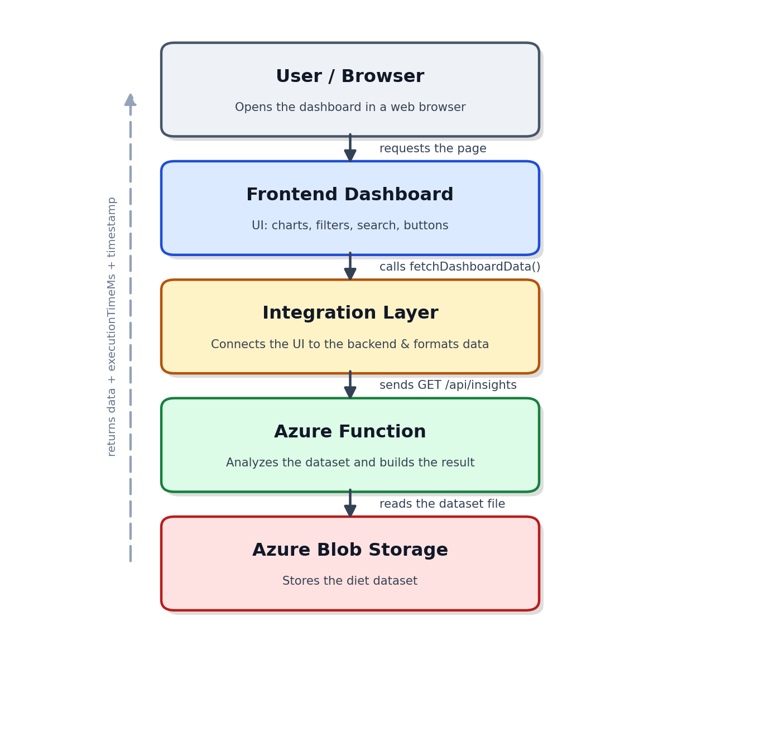
Figure 1 — Component overview and request flow

2. Services
Service / Tool | Purpose
Azure Function App | Hosts the HTTP-triggered backend that reads the dataset and returns analysis results.
Azure Blob Storage | Stores the diet dataset in the cloud.
Azure Resource Group | Organizes all Azure resources into one management group.
Azure Static Web App / App Service | Hosts the frontend dashboard.
Chart.js | Displays the Bar, Pie, Scatter, and Heatmap charts.
Fetch API | Sends HTTP requests from the frontend to the Azure Function.
Postman | Tests the Azure Function endpoint before connecting it to the frontend.

3. System Workflow
Step 1 – Deploy Backend
- Deploy the Azure Function to Azure Function App.
- Upload the dataset to Azure Blob Storage.
- Configure the required connection strings and environment variables.
Step 2 – Test the Backend
- Use Postman to test the Azure Function endpoint.
- Verify that it returns the expected JSON response.
Step 3 – Deploy Frontend
- Deploy the dashboard (HTML, CSS, JavaScript) to Azure Static Web App / App Service.
Step 4 – Load Dashboard
- The user opens the dashboard in a browser.
- The page automatically requests data from the backend.
Step 5 – Process Request
- The Integration Layer calls the Azure Function.
- The Azure Function:
  - Reads data from Azure Blob Storage.
  - Performs the analysis.
  - Returns the results with execution metadata.
Step 6 – Display Results
The dashboard updates and displays:
- Bar Chart
- Pie Chart
- Scatter Plot
- Heatmap
- Metadata (execution time, last updated, and data source)
Step 7 – User Interaction
The user can:
- Apply filters
- Search records
- Navigate through pages
- Click Get Insights, Get Recipes, or Get Clusters

4. Role Breakdown
4.1 Backend / Cloud (Jianning Li)

4.2 Frontend (Feven Ytbarek)

4.3 Integration (Utsanakorn(Kate) Chinkonglar)
4.3.1 Integration Layer Design
- The frontend communicates with the backend through a single function:
fetchDashboardData(endpoint, params)
- The frontend and backend share the following JSON response format:
{
"data": [...],
"executionTimeMs": 142,
"timestamp": "2026-07-14T10:00:00Z"
}
4.3.2 Visualizations Built
The dashboard includes the following visualizations:
- Scatter Plot: Displays the relationship between protein and carbohydrate values, with points coloured by diet type.
- Heatmap – Shows the Pearson correlation matrix for protein, carbohydrates, and fat using a colour-coded grid.
- Metadata Bar – Displays the function execution time, last updated timestamp, and current data source (mock or live).

4.3.3 Challenges Faced
Challenge 1 – Backend Not Yet Available
Problem
The Azure Function had not been deployed when the frontend integration began, making it impossible to test real API requests.
Solution
The team agreed on a common JSON response format before implementation. A mock data layer was created using the same structure, allowing frontend and backend development to proceed in parallel. After deployment, switching to the live API only required changing one configuration flag.

Challenge 2 – Scatter Plot Rendering Issue
Problem
The Scatter Plot displayed as a broken canvas, and the page became much taller than expected. Chart.js initialized before the Tailwind CSS layout was fully applied, causing the canvas size to be calculated incorrectly.
Solution
Each chart canvas was placed inside a container with a fixed height, and chart rendering was delayed until the browser's window.load event. This ensured that the page layout was complete before Chart.js calculated the canvas dimensions.

4.3.4 Screenshots
The screenshots below were captured from the running dashboard using mock data mode after the canvas rendering issue was resolved. The Scatter Plot and Heatmap display correctly, and the metadata bar shows the execution time, timestamp, and current data source.
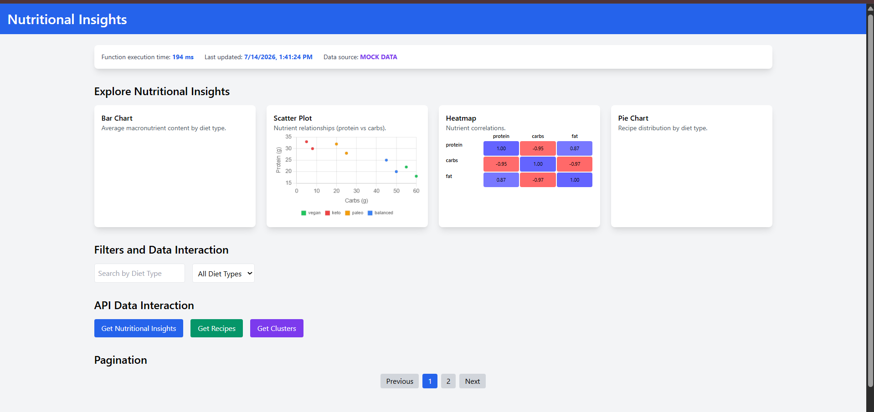
Figure 2 — Working dashboard: Scatter Plot, Heatmap, and metadata bar

